NEXTAG COMPANY

Gucci Zumi grainy leather card case wallet

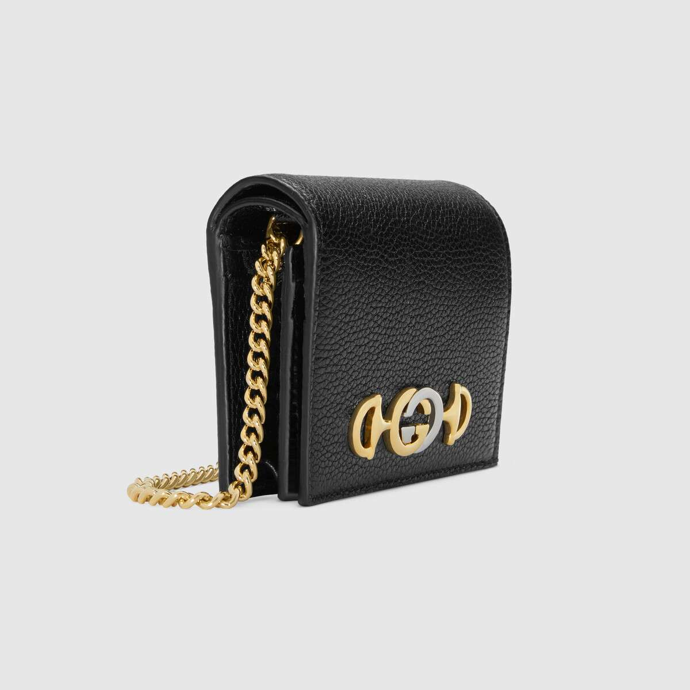

Style # 570660 1B90X 1000

Product Description

Hybrid design elements continue to shape the Gucci narrative. Completed by a detachable chain strap, the grainy leather card case wallet is enhanced by the Interlocking G Horsebit, a fusion of two of the House's most characteristic codes. Introduced in the evocative setting of the Théâtre Le Palace in Paris, the Gucci Zumi line takes its name from actress and experimental musician Zumi Rosow, who walked the Spring Summer 2019 runway carrying the bag.

Shiny gold- and silver-toned hardware • Zumi • Interlocking G Horsebit—inspired by an archival piece, the hardware combines two of the House's most historical motifs in a mix of metals

• Detachable metal chain with 4" drop • Five card slots • Interior open pocket • Interior zipper pocket • Snap closure • Made in Italy

PRODUCT DETAILS

Style ‎570660 1B90X 1000

Hybrid design elements continue to shape the Gucci narrative. Completed by a detachable chain strap, the grainy leather card case wallet is enhanced by the Interlocking G Horsebit, a fusion of two of the House's most characteristic codes. Introduced in the evocative setting of the Théâtre Le Palace in Paris, the Gucci Zumi line takes its name from actress and experimental musician Zumi Rosow, who walked the Spring Summer 2019 runway carrying the bag.

* Black grainy leather
* Shiny gold- and silver-toned hardware
* Moiré lining
* Interlocking G Horsebit—inspired by an archival piece, the hardware combines two of the House's most historical motifs in a mix of metals
* Five card slots
* Interior open pocket
* Interior zipper pocket
* Detachable metal chain with 4" drop
* Snap closure
* Open: 4.3"W x 3"H
* Closed: 4.3"W x 3.3"H x 1"D
* Made in Italy